# 4902 Project Deployment Artifacts

### Zachary Chenausky, Jigme Rinji Sherpa, Clay Lewis, Haris Javed, Saad Javed

1. Overview: The goal of this project is to give persons with visual impairments an accessible experience while not interfering with the workflow of people without any disabilities. Programming would be more convenient for everyone thanks to the extension's accessibility tools, which will enhance the whole experience. The most crucial accessibility elements for those with visual impairments will be included in the extension, such as:

* Outlining the scope of each individual line of code.
* line highlighting in a variety of styles and colors.
* Voice recognition enables time-saving code snippet installation as well as quick and simple accessibility option modifications.
* Filter intellisense suggestions.

1. Assumptions:

The user will have VScode and a screen reader (NVDA, JAWS, or VoiceOver)

● The user will have a Lego Mindstorm EV3, Spike Prime, or Thinker robot

● The user will have a microphone and the system has a sound card.

1. Dependencies:

"devDependencies": {

"@electron/rebuild": "^3.2.13",

"@types/glob": "^7.1.3",

"@types/mocha": "^8.2.2",

"@types/node": "16.x",

"@types/serialport": "^8.0.2",

"@types/vscode": "^1.60.0",

"@types/ws": "^6.0.0",

"@typescript-eslint/eslint-plugin": "^4.26.0",

"@typescript-eslint/parser": "^4.26.0",

"@vscode/test-electron": "^1.6.2",

"eslint": "^7.27.0",

"glob": "^7.1.7",

"mocha": "^10.0.0",

"typescript": "^4.3.2",

"vscode-test": "^1.5.2"

},

What the users must have installed:  
 "dependencies": {

"electron": "^24.2.0",

"electron-rebuild": "^3.2.9",

"serialport": "^11.0.0",

"server": "^1",

"vscode-languageclient": "^5.1.0-next.9",

"ws": "^6.2.2"

},

Python dependencies:

certifi==2022.12.7

charset-normalizer==3.1.0

click==8.1.3

colorama==0.4.6

idna==3.4

joblib==1.2.0

nltk==3.8.1

PyAudio==0.2.13

regex==2023.3.23

requests==2.28.2

SpeechRecognition==3.10.0

tqdm==4.65.0

urllib3==1.26.15

1. Constraints:

A constraint we face is when the user becomes disoriented within the editor, rendering them unable to navigate to their intended location. To address this issue, our mitigation plan involves implementing specific key bindings or commands that enable users to quickly access a designated home page for the extension. This home page will serve as a central hub from which users can easily return to their desired location within the editor, ensuring a seamless and efficient workflow. By providing these intuitive key bindings and a dedicated home page, we aim to empower users and alleviate the frustration caused by accidental disorientation, ultimately enhancing their overall experience with the extension.

Another constraint we face is the realization that VScode's compatibility with public screen readers falls short of its advertised capabilities. This shortfall becomes apparent when VScode incorrectly reads lines or fails to provide accurate information to the user. To tackle this challenge, our mitigation plan involves implementing specific functions within the extension that optimize content specifically for the user's chosen screen reader. By tailoring the output to suit the screen reader's requirements, we aim to enhance the accuracy and reliability of the information conveyed, ultimately ensuring a smoother and more accessible experience for users relying on screen readers while utilizing the extension.

1. Description of Deployment Artifacts:

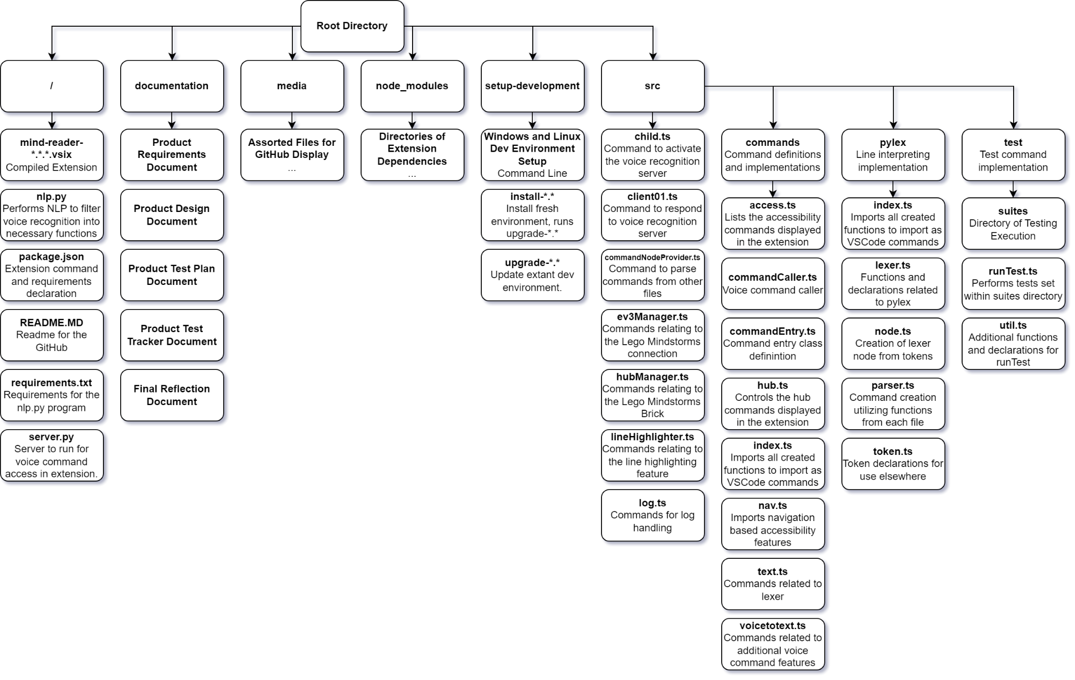

1. Data Creation: N/A
2. Admin Credentials: N/A

8. Deployment process

Developer’s Install Guide:

## Automated install script

### Windows 10 or 11

* Download [install-windows.ps1](../blob/master/setup-development/windows/install-windows.ps1)

* Run `./install-windows.ps1` in PowerShell as a normal user, and accept any UAC prompts that pop up. The installation should take around 8 minutes. If an installer doesn't pop up, don't be alarmed.

### Ubuntu, Linux Mint, Arch Linux, Manjaro

* Download [install-linux.sh](../blob/master/setup-development/linux/linux-install.sh)

* Run `install-linux.sh` as a normal user. It will use sudo when elevation is required. The installation should be done in 3 minutes.

## Manual install

### Windows

#### Windows 11

1. Open Powershell in Windows Terminal (Commands will be in parentheses)

2. Open VS Code, and go to `Help` > `About` in the top toolbar.

3. Install/update Git for Windows (`winget install Git.Git`)

4. Install the version of NodeJS.LTS corresponding to your Visual Studio Code version. This can be found in `Help` > `About` in the toolbar. (`winget install OpenJS.NodeJS.LTS --version <NodeJS version>`)

* This prevents a NODE_MODULE_VERSION conflict between Mind Reader and VSCode

5. Use node package manager to install `electron-rebuild` and `vsce` (`npm install -g electron-rebuild vsce`)

6. Change to your git directory, or create one. I recommend `C:/Users/<username>/git`; i.e. `C:/Users/example/git`

7. Clone the repository using (`git clone https://github.com/jcode999/Mind-Reader.git`)

8. Install dependencies (`npm install`)

9. Rebuild Electron using the Electron Version from the About page. (`electron-rebuild --version <Electron version>`)

* This will rebuild the `serial_port` Node Native Module. Without this module, Mind Reader will fail to register its commands.

10. Repeat steps 5-8 each time Visual Studio Code updates.

#### Windows 10

1. Install/update Git for Windows

2. Open VS Code, and go to `Help` > `About` in the top toolbar.

3. Install the version of NodeJS.LTS corresponding to your Visual Studio Code version. This can be found in the About page.

4. Open Windows Powershell (Win+R, "powershell", Enter)

5. Use node package manager to install `electron-rebuild` and `vsce` (`npm install -g electron-rebuild vsce`)

6. Change to your git directory, or create one. I recommend `C:/Users/<username>/git`; i.e. `C:/Users/example/git`

7. Clone the repository using (`git clone https://github.com/jcode999/Mind-Reader.git`)

8. Install dependencies (`npm install`)

9. Rebuild Electron using the Electron Version from the About page. (`electron-rebuild --version <Electron version>`)

10. Repeat steps 4-8 each time Visual Studio Code updates.

User Installation guide:

Follow these steps to install Mind Reader using the VSIX file

#### 1. Download the VSIX file

https://github.com/We-Dont-Byte/Mind_Reader/releases/latest

#### 2. Installing through Visual Studio Code

Navigate to the Visual Studio Code extensions tab

Under extensions, there are 3 dots "..." representing "Views and More Actions"

Click on "Install from VSIX"

Using the file explorer, navigate to the downloaded VSIX file from step 1

Simply click on the VSIX file and click install